Session 2: Writing Your First C Program - Topics:Setting Up Environment -Installing a C Compiler (e.g., GCC), Choosing an IDE (DevC++. VS Code, Codeblocks, etc) Basic structure of C program (header, main, return).Compile and run using GCC or VS Code terminal.Example: “Hello, TOPS Technologies!”

- Install GCC on your computer and verify the installation by running gcc --version in your terminal or command prompt

- Open VS Code or DevC++ and create a new file named hello.c. Write a C program that prints 'Hello, Instagram World!' to the console.

Code-
#include <stdio.h>

int main() {
printf("Hello, Instagram World!\n");
return 0;
}

Output-
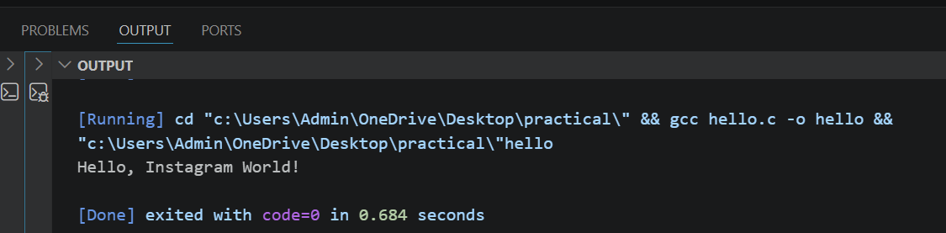

- Identify and label the header, main function, and return statement in your hello.c program using comments

Code –
#include <stdio.h> // Header file

int main() // Main function
{
printf("Hello, Instagram World!\n");

return 0; // Return statement
}

Output-


- Compile your hello.c file using the GCC command line (gcc hello.c -o hello) and run the output file to display the message in your terminal.<br><br><em><strong>Hint:</strong> On Windows, the output file will be hello.exe; on Linux/Mac, it will be hello.</em>

